**Terraform State File Explanation With Different Scenarion**

This file Track the resources in remote location.

1. When we run for first time plan and apply than it will go to AWS service and the resourses will be create and the aws remote current changes will store in terraform state file.

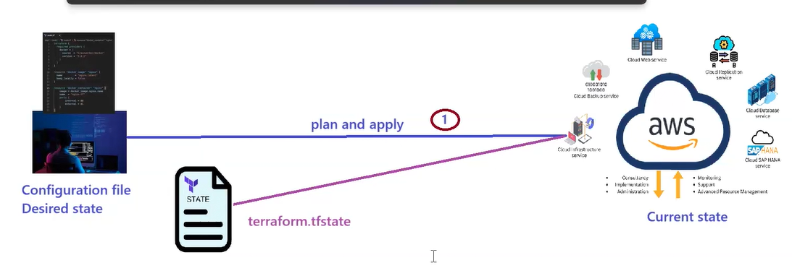

1. When any developer execute plan command after first execution than it will so as a no change because when it will go to AWS service than it will refresh and check from desire state to current state as is there any changes. If any changes than it will apply otherwise only refreh.

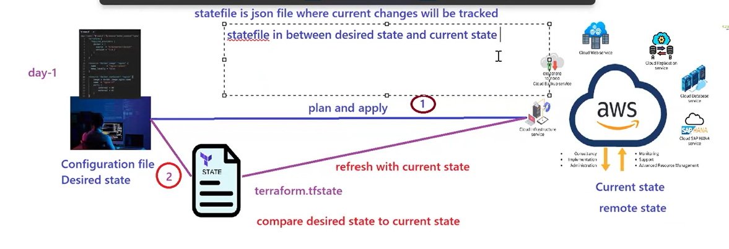

1. Every time configure secret key using aws configure command.
2. Write main.tf and provider.tf. When we will execute terraform apply command than state file will create and it will store the remote changes. If we will run same change for 2nd time than It will show as no change. So when will execute plan that time we need to see what are the changes are going to modify.

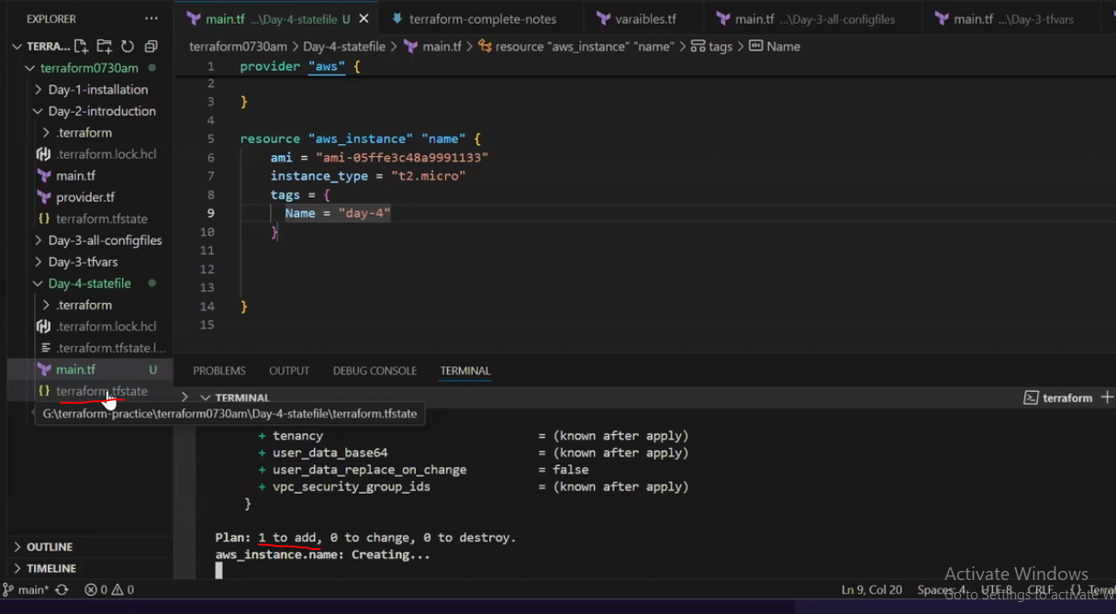

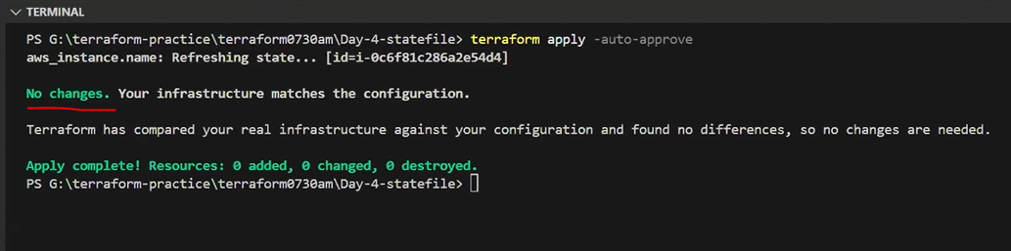

1. If we will delete the state file and execute once again plan and apply than we will see again as 1 resourse will add because remote aws current changes is removed . so there is no track that why it will create once again. So we are very careful to satefile.

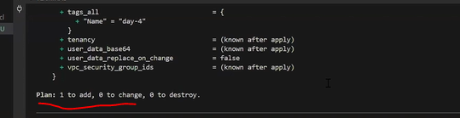

1. If we will change anything in resourese in main.tf and after we will apply than it will 1 Change not as create. Than it will refresh and stop the server and update from micro to nano and start the server.

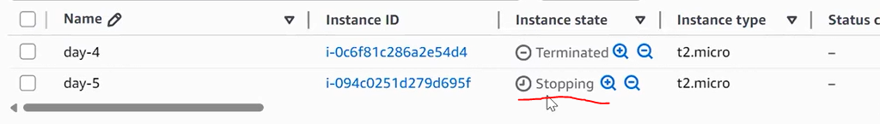

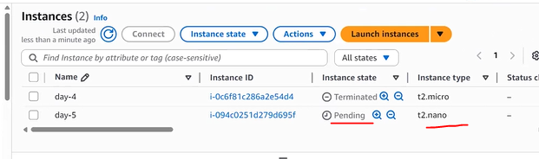

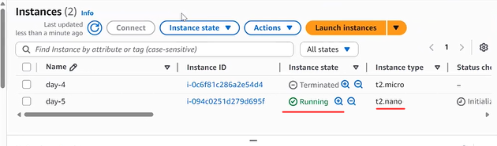

1. If we will modify ami or key in main.tf. When we will run plan than it will show 1 destory means it will destroy the instance because after instance creation we can’t modify ami. That’s why it will destroy and if modify ami Is correct than it will create another instance otherwise in apply command it will through error. So be careful in plan command which attributes are enable to midify after creation.

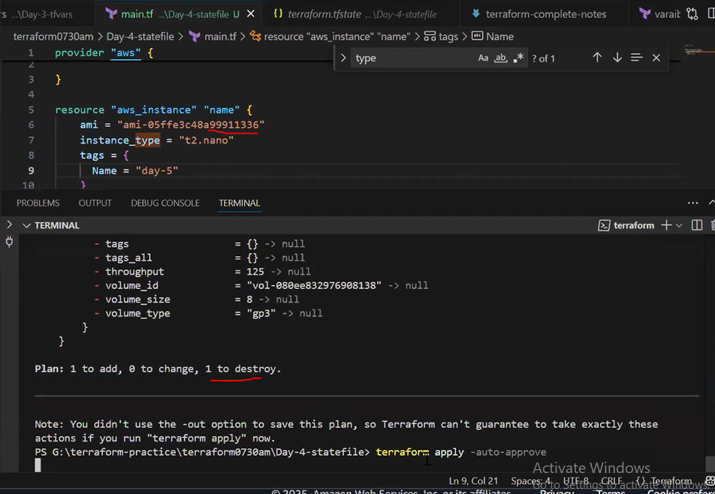

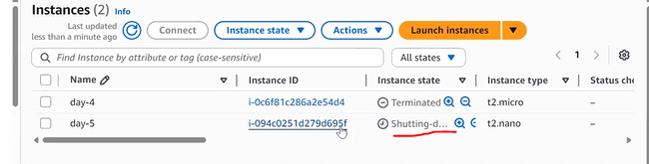

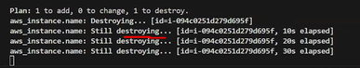

After destroy completion when creating its throw error.

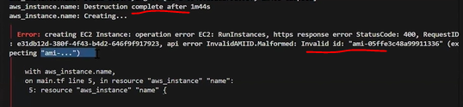

1. If we will add a S3 bucket. Once its created than we are removed s3 code in repo and run the plan,apply than it will destroy the resource. Because desire state and remote change is different.

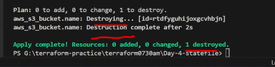

1. If Instance type is changed in state file from nano to micro but its not changed in main.tf or remote(AWS). Then it will check what is remote and main.tf . is there any changes ? if not than it will update same as it is in state file to nano.

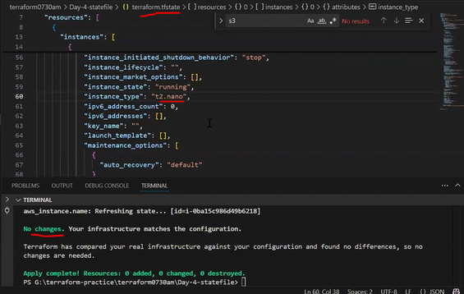

1. Mannually Modify the instance type in remote from Nano to micro. We can’t modify with out stop. First stop the server and than modify. Than we will change instance type in remote. When interview ask question than we should ask as what should be the change.

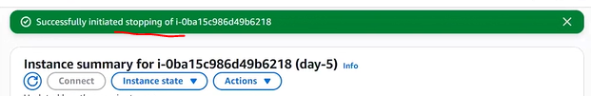

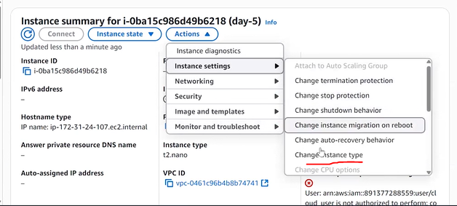



Once manually change completed than start the server and in locally execute terraform plan with same existing code. Then it will show as drift.

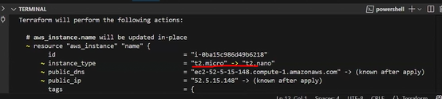



If anyone changed manually in remote. When we will execute terraform plan than it will show as drift.

Its showing as my main.tf is nano but its coming as it will change from micro to nano means some one did changes in remote. That’s why when we will apply in remote have instance as micro but our main.tf is nano. So it will update as 1 change from which is in main.tf as nano.

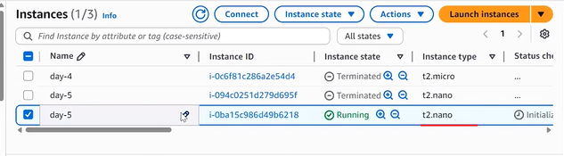

1. If someone changed in remote from nano to micro which is correct but when I am running in local than its showing as 1 change which is micro to nano.but we want to keep same micro when we will run in local than when terraform plan will saw one change as micro to nano than in main.tf we will update as micro. So that it will show as no change.

Here tag is changed from day-5 to day-6. If this is correct than we will update same in local. So that it will not change again to day-5.

